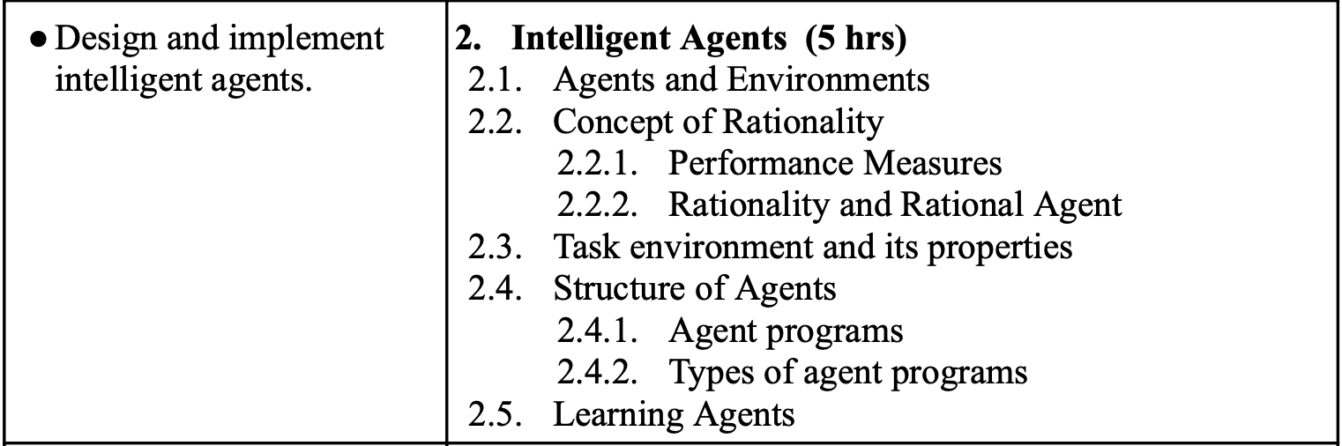

1. How do simple reflex agents work, and what limitations do they have? Discuss the strengths and weaknesses of simple reflex agents compared to more sophisticated types of agents.
2. Explain the concept of goal-based agents. How do goal-based agents differ from reflex agents, and what is the role of goal formulation in their decision-making process?
3. Define the concept of a task environment. What properties does a task environment have, and how do these properties influence the design and functioning of intelligent agents within that environment?
4. Discuss the role of learning in intelligent agents. What is the significance of learning for an agent’s ability to adapt to changing environments, and what methods can be used for agent learning?
5. Comparing PEAS of Two Agents

Compare the PEAS descriptions for the following two intelligent agents:

I. **A medical diagnostic system** that suggests possible diseases based on symptoms provided by a user.

II. **A customer service chatbot** that assists users with inquiries on an e-commerce website.

* What are the key performance measures for each agent?
* How do their environments differ (e.g., data sets, user interactions)?
* What sensors and actuators are utilized in these systems?
* How does the environment influence their respective PEAS components?

1. Identifying PEAS for a Vacuum Cleaner Agent  
   Define the PEAS components for a robotic vacuum cleaner agent operating in a domestic environment. Consider the following scenario:

* What are the **performance** measures for the agent to be considered successful?
* What **sensors** and **actuators** are required for the agent to operate effectively?
* How does the **environment** impact the agent's operation?